BASIC PYTHON
INPUT () AND PRINT () FUNCTIONS
input():
input () is a predefined function that helps to get a customised value from the user during execution time in string format.
Print ():
print () is a predefined function that helps to display the output on the screen.
Example:
var = input ("Enter a value: ")
print(var)
print(type(var))
print ("===============================")
n1 = int(input("Enter the first number: "))
n2 = int(input("Enter the second number: "))
sumval = n1 + n2
print("Sum value is:", sumval)
print(type(sumval))
print("===============================")
TASK:
Write programs for Subtraction, Division, and Multiplication.
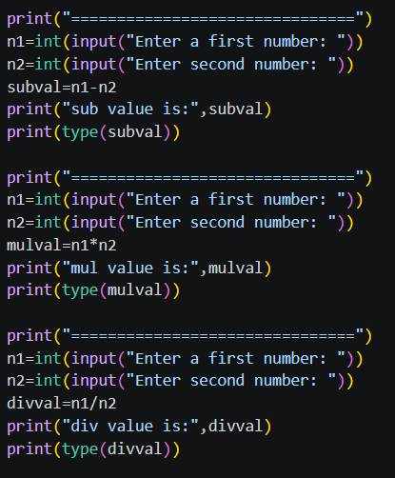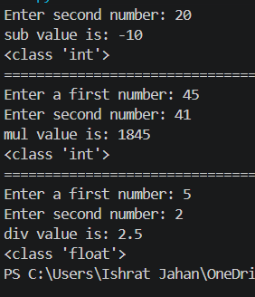
--------------------------------------------------------------------------------------------------------------------------------

OPERATORS
An operator is a special symbol or keyword that is used to operate on values.
Example:
7 + 34
Operands: 7, 34
Operator: +
Operation: Addition
Operands: Operands are the values that are involved in an operation.
Operator: An operator is a special symbol or keyword that has built-in functionality, based on which an operation is performed on values.
Operation: An operation is an action that is performed on values based on the operator used.
TYPES OF OPERATORS
There are 7 types of operators:
- Arithmetic Operators
- Comparison / Relational Operators
- Logical Operators
- Bitwise Operators
- Assignment Operators
- Membership Operators
- Identity Operators

- Arithmetic Operators:
- To perform mathematical operations on numbers
- I/P: numbers • O/P: number
- +, -, *, **(exponentian), //, /, %

+:
  - When used with a minimum of 2 numbers, it performs addition
  - When used with a single number, it represents a +ve number
Ex:
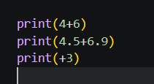

-: When used with a minimum of 2 numbers, it performs subtraction
When used with a single number, it represents a -ve number
Ex:
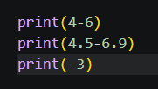

*: When used with a minimum of 2 numbers, it performs multiplication
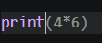

**: it returns the exponent value of the given base and power
Base ** power

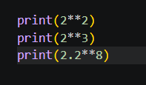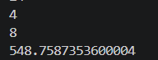

//: Floor division /: float division %: modulo
Ex:
Floor division (non-decimal quotient)
Remainder (internal performs the floor division)
Return decimal quotient
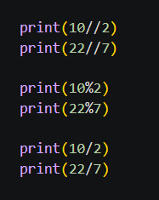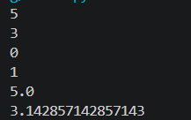

- Comparison / Relational Operators
- It is used to compare the minimum of 2 values
- It returns a Boolean value (True or False)
- Any values can be taken as input
- >, <, ==, >=, <=, !=
True, False, and None are special kinds of keywords that hold values (the first letter is uppercase)
True 1
False 0
None nothing

Ex:
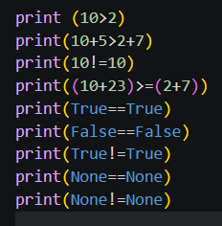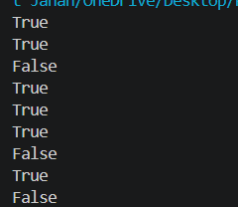

6/10/2026
- Logical Operators
- It is used to combine and check multiple Boolean conditions
- I/P: Boolean condition, anything that represents the
  - Boolean condition
    - Direct bool_val or anything that represents a Boolean value
    - An expression that returns a Boolean value or anything that represents a Boolean value
    - Any variable that holds a Boolean value; anything that represents a boolean value
- Boolean value or anything that represents bool values
- Types: and, or, not
NOTE: Any non-zero values are considered to be true
Any empty objects, “”, 0, (), {}, [], False, and None are considered to be false

AND:
Cond 1 | Cond 2 | O/P
T | T | T
T | F | F
F | - | F
- If the initial condition is False, it will not check forward

OR:
Cond 1 | Cond 2 | O/P
T | T | T
T | F | T
F | F | F
F | T | T
- If the initial condition is true, then it won't check the next condition

NOT:
- It accepts only one single operand to perform the operation
- It strictly returns true or false
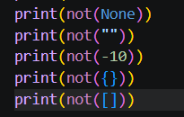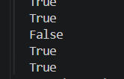
- Bitwise Operators
Types:
  - Bitwise and &
  - Bitwise OR |
  - Bitwise not/negation/complement ~
  - Bitwise left shift <<
  - Bitwise right shift >>
  - Bitwise unsigned left shift <<<

- Assignment op:
  - Commonly, it doesn’t return any value
  - It stores /copies value mentioned on the RHS to the named memory location on the LHS
Syntax:
Var_name1=val [initialisation]
Var_name2=var_name1[copying]
Var_name2=val [re-initialisation]

- Membership operator:
- It checks whether the specific element is present in a group of elements or an iterable object or not
- It returns only a Boolean value
Iterable object: an object that holds multiple individual elements in the same shared memory location

e.g., list, string, set, tuples, dictionary
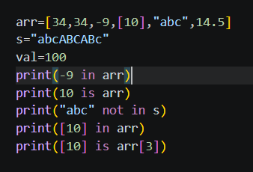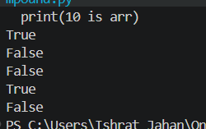

- Identity op: [is, is not]
- It compares the IDs of the given values
- It returns only Boolean values
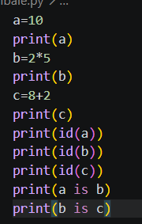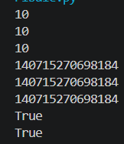

--------------------------------------------------------------------------------------------------------------------------------
VAREABLES
- It is a named memory location that holds single-valued data
- It is a name that is given to a container that holds data
- If we try to store the same value into different variables, then internally all the variables will be pointing to the same shared memory location
NOTE: id() is a predefined function that displays the ID value of the provided data
It is an integer value that is generated by PVM during execution time based on the value stored or memory allocated.
- If multiple values are tried to be stored into the same variable one after the other, then internally different memory will get allocated for each initialisation
- It is compulsory to initialise a variable before utilisation

VARIANTS OF VARIABLES [Compound statement]
- Arithmetic + Assignment: +=, -=, **=, //=, /=, %=
- Bitwise + Assignment: &=, |=, ^=, <<=, >>=, <<<=
Rules:
- Whenever the operand used on the RHS for the operation and the LHS for updating is the same
- It is compulsory to use initialized vars
- Apart from the initialised vars, even direct constants can be used
- A minimum of 2 operators are required to perform the operation
- The operand which is used on the RHS for operation and LHS for updation should be present on the LHS of the operation
Eg:
a = a + b valid
a = b + a not valid
Note: ~= is not included under compound statements, as it requires only a single operand to perform the operation
Eg: Compound statement
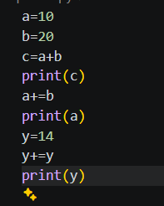
--------------------------------------------------------------------------------------------------------------------------------
Control flow statement
- The statement that controls the execution flow of the program
- Type:
  - Conditional statement
- simple if
- if-else
- elif ladder/if-else-if ladder
- shorthand

  - Looping statement
- for loop
- for with range ()
I. increment
II. decrement
- for without range()
- while loop

  - Jumping statements
- break
- continue
- return

For loop: range ():
  - It is a predefined function that helps to execute the defined sequence values internally
Syntax: range(start, stop/end, step)
  - Start, stop, step 🡺 only be integers
Startfrom where the sequence should begin. The default start is 0
End/stop It is compulsory to be passed.
Defined TILL where the sequence should be executed
Step: the difference between the current element and the next element; the default start is +1
- for with range ():
for var_name in range (start, end, step):
#logic
#remaining statements
- increment for loop:
For var_name in range (start, (actual end+1), positive_step):
#logic
# remaining

Write a program to display the natural numbers from the beginning with a difference of three up to n, where n is also included.
Rules:
  - Pass a positive step
  - Start < end value
  - If the actual end value also needs to be included, then (actual end + 1)

- Decrement for loop:
For var_name in range (start, (actual end-1), negative_step):
# logic
# remaining
Rules:
  - Pass a negative step
  - Start > end value
  - If the actual end value also needs to be included, then (actual end - 1)

Display the natural numbers starting from n to 1 in decreasing order with a difference of 4
b. for without range
- A for loop without range () is used to iterate directly over the elements of a sequence such as a list, tuple, string, or set.
- Syntax:
for variable_name in iterable_obj/group_of_elements :
statements

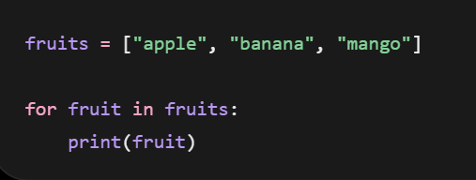
Rules:
  - No single-value data
  - The cursor moves in the forward direction
  - It directly fetches each individual value
  - Even empty iterable objects work
  - A group of elements can be passed by separating them using commas
Note:
  - For with range when used on an iterable object like an array/string, it represents the index
  - For range without, when used on an iterable object like an array/string, it represents values
  - 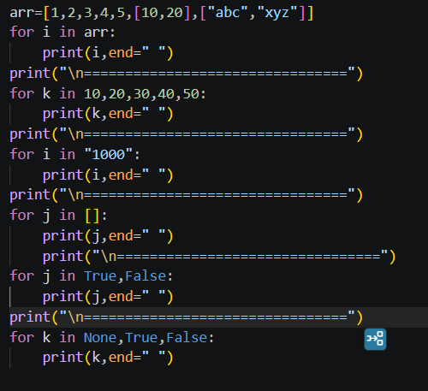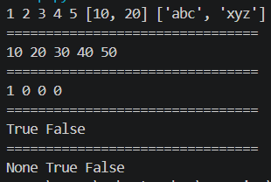

7/10/2026
While lop
-----------------------------------------------------------------------------------------------------------------------
- There are 2 variant of variables that acne be involved in while loop:
  - Looping var
  - Condition var

- Syn
#initialize the var involved
While bool_cond:
#logic
#updation statemen
#remainting stmts
Eg: WAP display whole numbers starting from n with ain a decrementing order with an incrementing difference
Can range be use with while “YES” but there is no logically use of it

Jumping Statement
- BREAK:
- Keyword that helps to exit the current loop in which it is present
- Continue:
  - Keyword that helps to skip the the current cycle logic and updates to the next cycle
Functions:
-------------------------------------------------------------------------------------------------------------
- Independent block of code included to perform a specific action based on input provided
- A function can execute its logic when it is being called
Syn:
#function declaration
def function_name(parameter):
#logic
return val/ val’s
Function call
var_name=function_name(arguments)
Parameters: the input that is required by the function to execute the logic
Arguments: the values that are passed to a function during the function call for it to execute the logic
Return: is keyword it’s
- a last executable line of code within a function
- once the return works no other line of the code within the function will execute
uses: it return the PVM to take back the execution flow from called function back to the function call.
- it helps to retun val or val’s from called function back to the function call

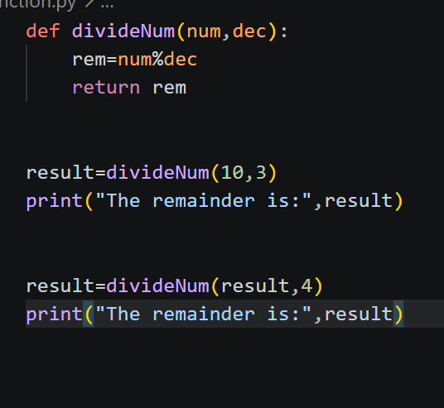

LEAP YEAR
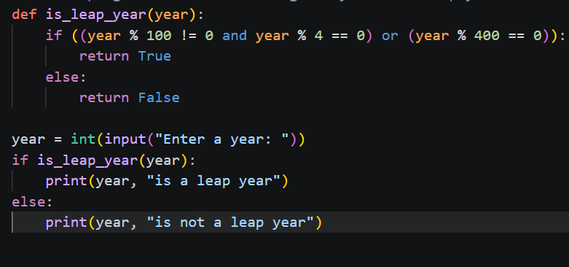
Optimised solution:
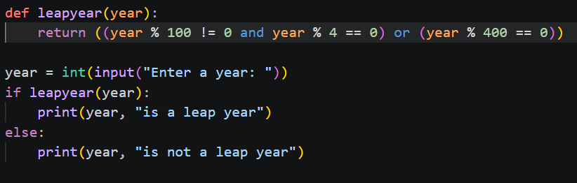

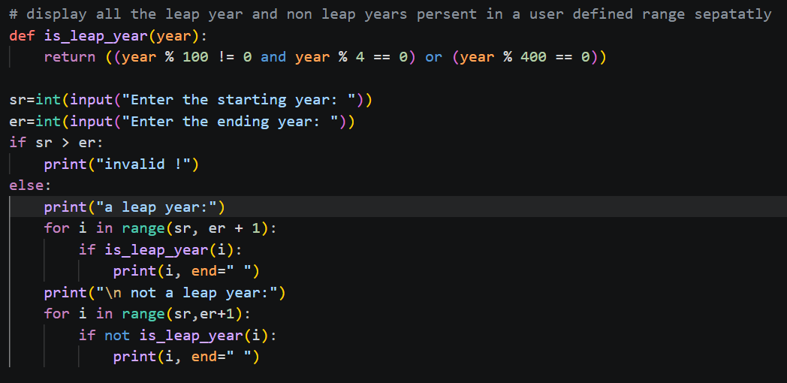

08/10/2026
COUNTING the digiths in a number
WAP count the number of digits
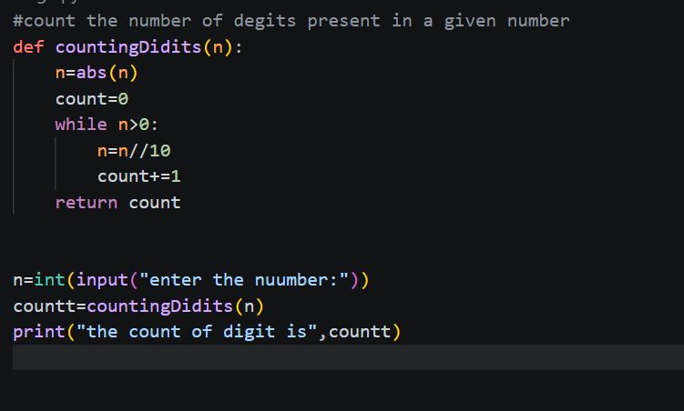

Armstrong number
Write a program to check weather the given number is an Armstrong number or not
ASN: if the sum of the exponent value (base == >each digit, pow -- >tot count of digit in a given number) of all the digits
- WAP to display all the asm number present in a user user defined range

- WAP To display the all ams number and non-armstrong number in user defined range separately
- WAP to display the first n Armstrong number
- WAP to display the first n non-Armstrong number
- WAP to display the first n Armstrong number and non amstrong number separately

REVERSE the given number
6. WAP to reverse all the numbers present in a user defined range

7. WAP to reverse all the numbers present in a user defined range
In decrementing order

- WAP to reverse all the numbers Only the odd number present in a user defined range
Others as it is
Eg: 97 98 99 100 101 102
79 98 99 100 101 102
- WAP to reverves all the number in a user defined range and display the even and odd number separately

Reveres even num are: notes
-------------------------------------------------------------------------------------------------------------
Integer palindrome:
A number is said to be an ingeger palindrom only when reversal of an orginal number is same as the original number
- WAP to check Give number is an integer palindrome or not
- WAP to display all the integer palindromes present in a user defined range
- WAP to display all the non-integer palindrome present in a user defined range
- WAP to display all the integer palindromes and non-integer palindromes present in a user defined range separately
- WAP to display the first n integer palindromes
- WAP to display the first n non integer palindromes
-------------------------------------------------------------------------------------------------------------
Factors:
An element is said to be a factor of a number when a element is able to divide and reduce the number down to 0.
- All factor of a given number will lie within range 1 to number itself
- Least factor 1
- Highest factor is number itself
WAP to display the factors
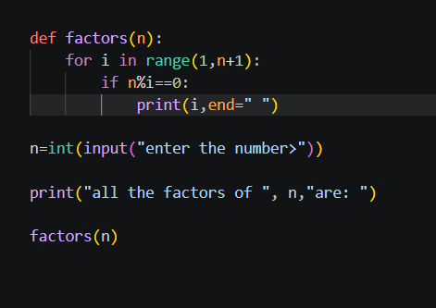
- WAP to display count the factors of a given number
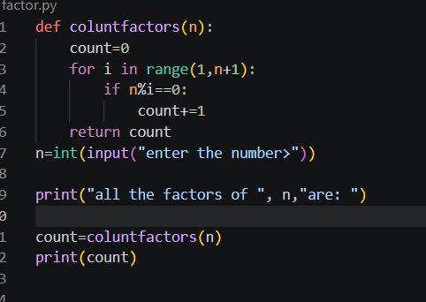
- WAP program to count a number of cycle to display or count the factors of given number
- 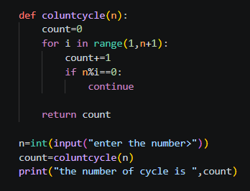
Logic 2:
  - All the factors of a given number can be displayed within the range of 1 to direct square root of the given number or lower nearest square root of the given number
- WAP to display all the factor of user input
Count the factor
- Wap to display all the factors of each and every number present in a user defined range (both the logic)
ex: st=8 ed:12
the factors of 8 is: 1 2 4 8
the factors of 9 is:
the factors of 10 is:
the factors of 11 is:
the factors of 9 is:
the factors of 9 is:
- WAP all the factors to display 1 n number
eg count=4
the factors of 1 is :1
the factors of 2 is:1 2
the factors of 3 is :1 3
the factors of 44 is
- WAP all the factors to display 1 n odd number
Eg count=10
the factors of 1 is :1
the factors of 3 is:1 3
the factors of 5 is :1 5
the factors of 7 is :1 7
the factors of 9 is :1 8
-------------------------------------------------------------------------------------------------------------Prime numbers: the number which has exactly two factors ex: 1and the number itself
There are no negative prime numbers
- WAP to check the weather the give number is prime number or not
- WAP to display the prime number in user defined range
- WAP to display the non-prime number in user defined range in decreasing order
- WAP to display first n prime number
- WAP to display first n non-prime number
-----------------------------------------------------------------------------------------------------------
HCF / GCD:
  - Highest common factor/ greatest common Divisor
  - For given 2 number which is the highest ele that can commonly divided and reduced the I/P num’s down to 0. That ele is said to be HCF
Co-prime number
  - The given 2 numbers are said to be co-prime to each other if and only if GCD of the numbers e exactly 1
- WAP to check weather a given 2 numbers are co-prime or not

Fibonacci series:
- N1 display the current cycle value
after which it holds the net cycle value
- N2 initially, holds that next cycle value
Holds the future cycle value value
- Pos keep the track of number of cycles
- Temptemporary memory which holds the future cycle val before changing current(n1) and next(n2) cycle values
WAP to display the Fibonacci for the provided position
1. using decremeting while loop
2. Using uncrememtion loop
3. Using decrememtion for loop
4. Using Increnenting for loop

Recursion:
Process of function calling itself for certain number of types
Syn: 1. Where there is no return value
def function name (parameters):
#base condition
#logic
#recursive function call
#fun_name (argument)
#initial function call
func_name(argument)
Syn: 2. Where there is return val
#called function
def function name (parameters):
#base condition
#logic
#recursive function call
#fun_name(argument )
#initial function call
var_name=func_name(argument)
Base cond the comdition that control which control the recursive function call
it is decided based on when should the recursive call stop

RecursionErroor it is thrown by the PVM when the memory resource is asked beyond the avaliblity
It is generally led:
1. when there is unlimited recursive call;
2. When the I/P num is very huge
Initial function cakkIt is the first cakk of a function, without it no function will be executed
--it generally would be outside the recursive function which it is calling
--tn recursive the argument passed should be the first value for the parameters

Recursive function call-it is the call that is made to repete the logic
it is placed within which the function ned to be repeated
it recursuiron , the argument passed should be the
1. The updsted value that needs to be carry forward to the next cycle for the further operations
2. The val which may not be updated bu is required by the next cycle

- WAL to display 4(n) to 1 in decrementing order without using loops and
- The condition which control the recursion call is call base condition
WAP to display 1 to n in incrementing order
WAP to display the below series by getting user defined n
n=4
43211234
no change in base condition
no change in recursive function call
no 3rd variable allowed

WAP to display the below series by getting user defined n
N=4
1 2 3 4 4 3 2 1
WAP to reverse an integer(+ve) Number using recursion
WAP to count the digits in a given number using recursion
WAP to display finocicci series for the given position

Nth Fibonicci number:
WAP to give the n^{th} fibno number
WAP to give the factorial of the give number

Fact,GCD

Factors:
WAP to display the factors of the given number for 1 to n

GCD:
Euclidian Algo:
Given two numbers n1 and n2
Gcd(n1,n2)-\ = gcd(n1%n2,n2)
Where n1>n2
Rpeat the cycle until n1==1 once n1=1 then n2 is gcd

HAPPY Number:
A number is said to happy if it id exactly 1 and un happy If it is exactly eqyal to 4 if any other number it should be square for each individyal digit get the sum of the suquare od each digit and keep repeting it util its been reduce to 1 or 4

Patterns:
- Are the combination of rows and column
- Rows are the sleeping line /vertical line
- Column are standing /vertical line
- To keep the patterns daynamic make the count of number of rows as customized (4<=n<=15)
- Once the cursor move to next line, it cannot be bought back to the previous line
- Cursor moves from top to bottom and left to right approach
- Varie ties of pattern : start, Number,Alphabet
- Types :
  - Non -Combinational Patterns:triangles, square,parallogram
  - Combination Patterns: K-Patterns, Trinagle, Dimond, Butterfly
- Print(): to move the cursor control to the beginning of the next line if any val has been passed then display it and move the cursor control to the beginning of the next line
- “i” is always dependent on n value
- “j” should b dependent ok n or I or any other third variable

Non-Co mbinational:
1. 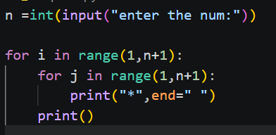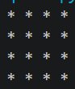
2. 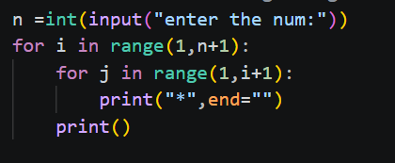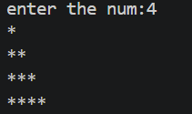
3. 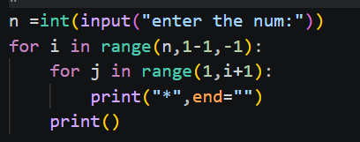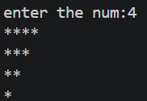
4. 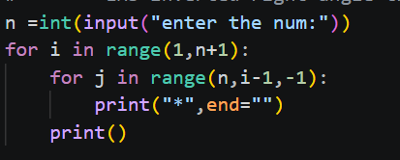
5. 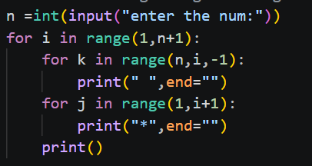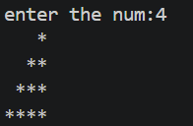
6. 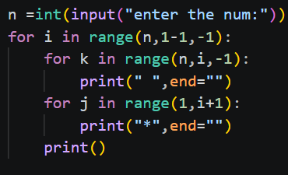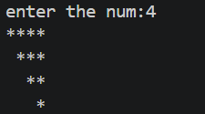
7. 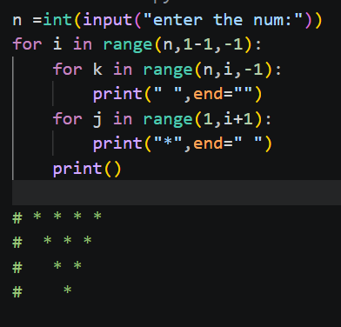
8. 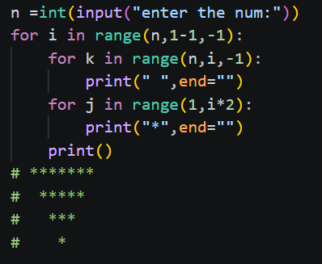
9.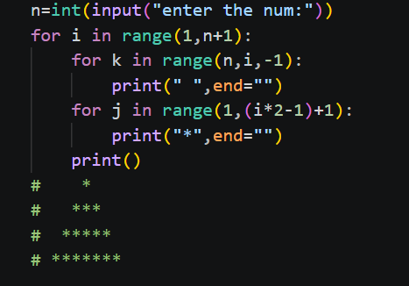
10. 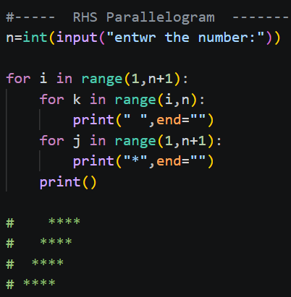
11.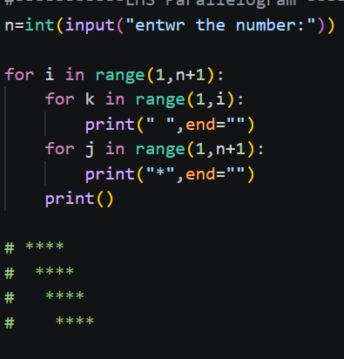

Combinational--Ptterns
1. 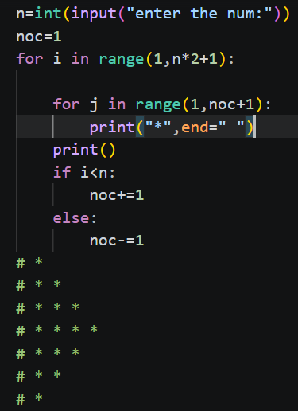
2. 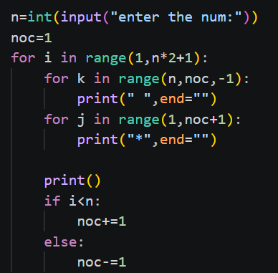 

3. 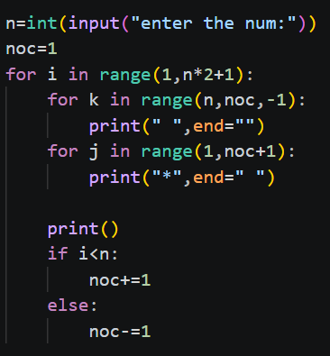 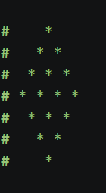
4. 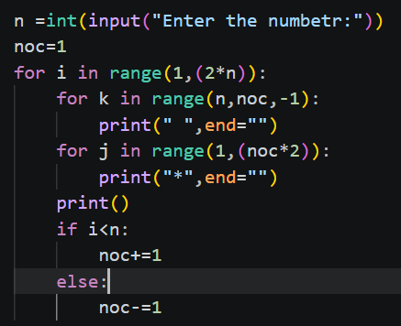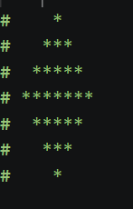
5. 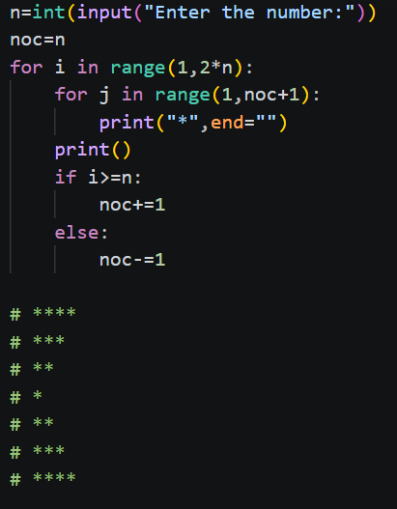

6. 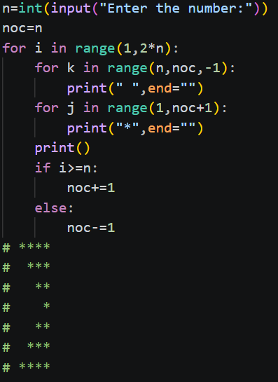

7. 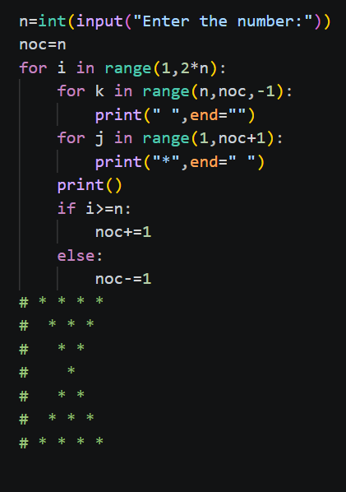

8. 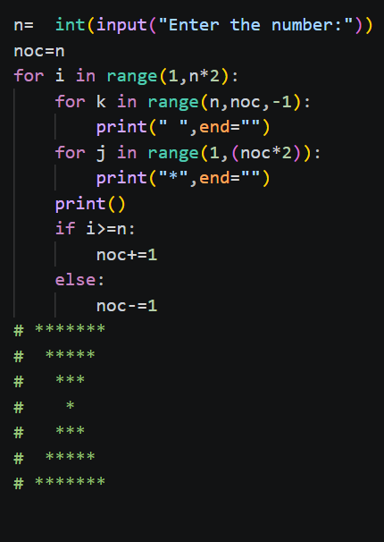

9. 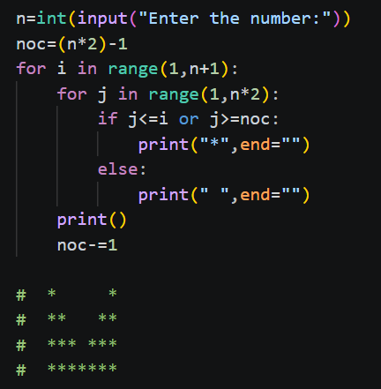

10. 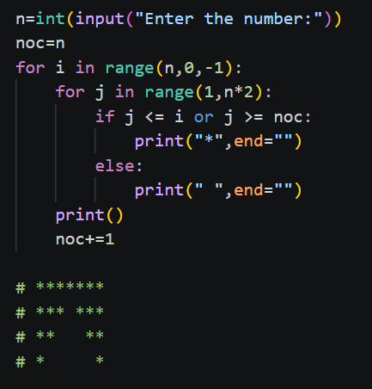

11. 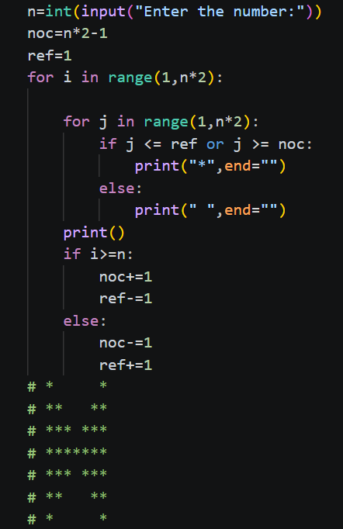

Number -Pattern:
1. 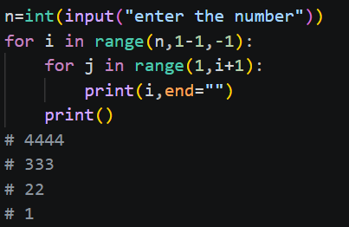
2. 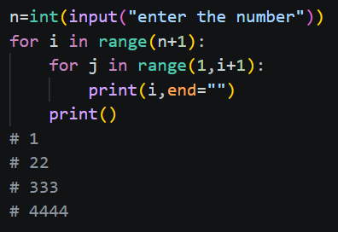
3. 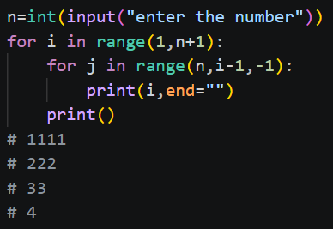
4. 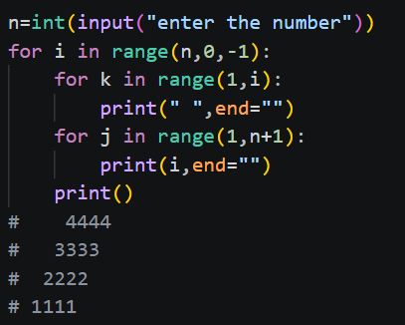
5. 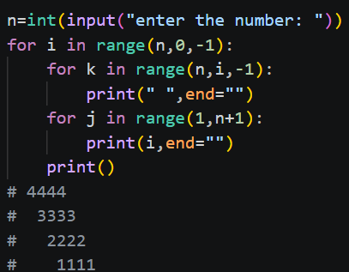
6. 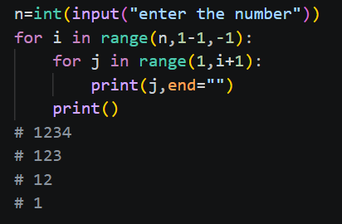
7. 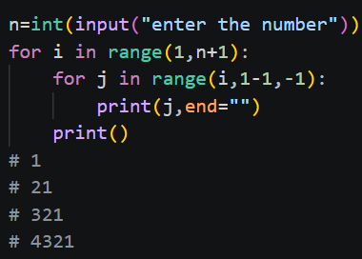
8. 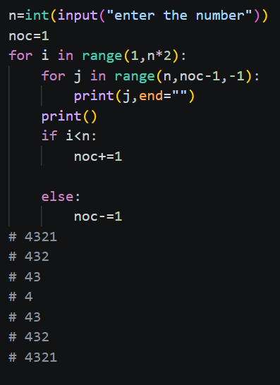
9. 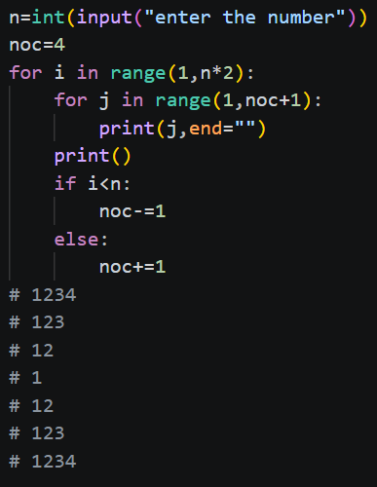

10. 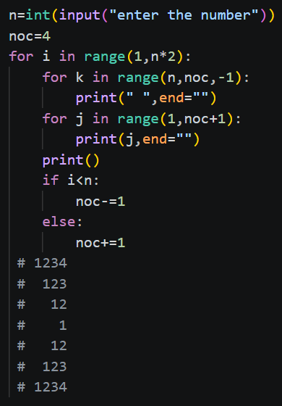
11. 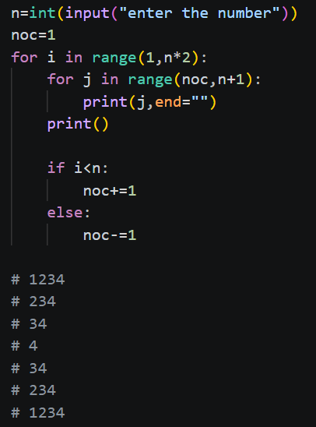
12. 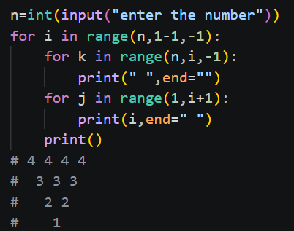
13. 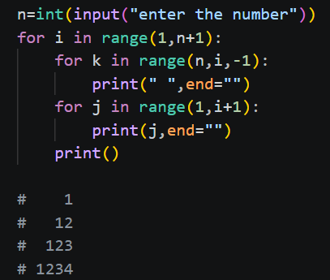
14. 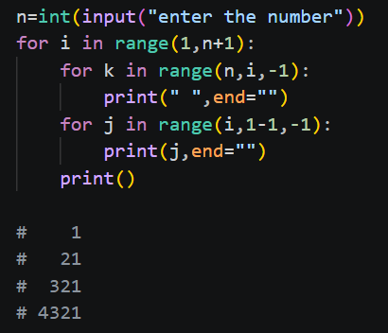
15. 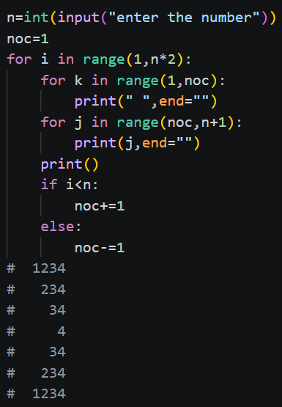
16. 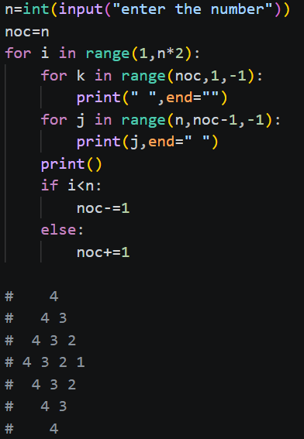
17. 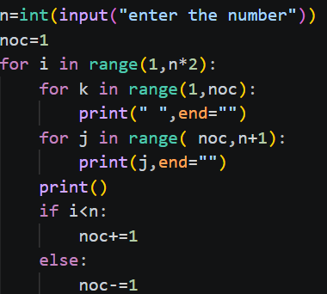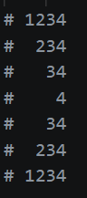
18. 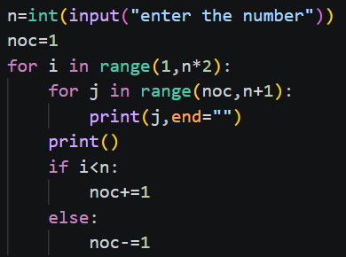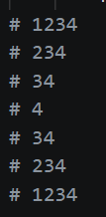
19. 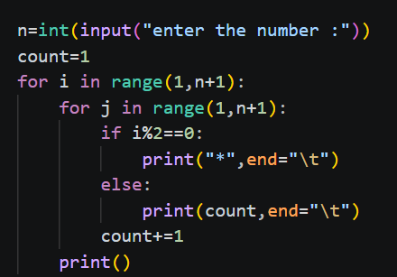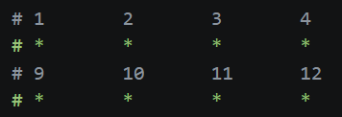
20.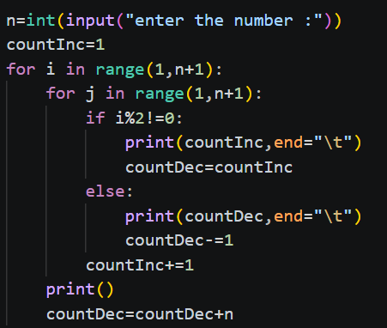 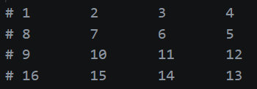
21. 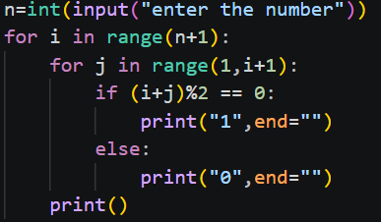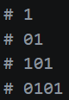
22. 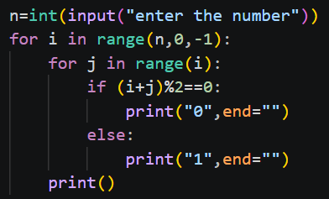 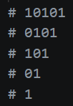
23. 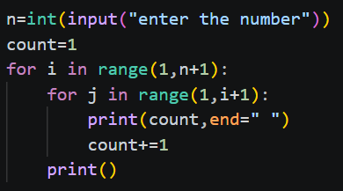 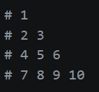
24. 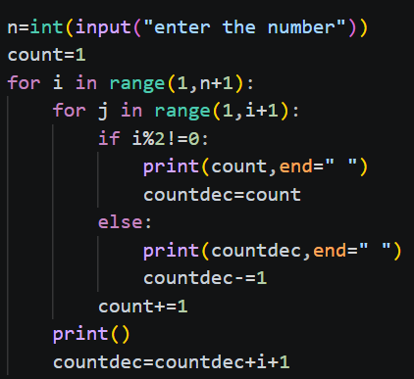 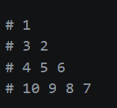
25. 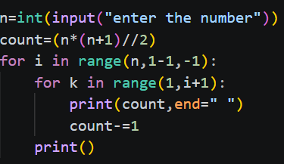 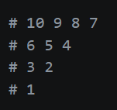
26. 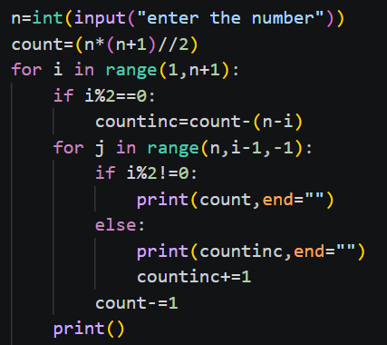 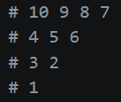
27. 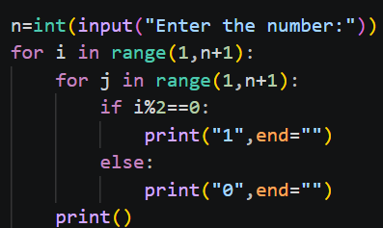 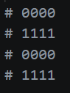
28. 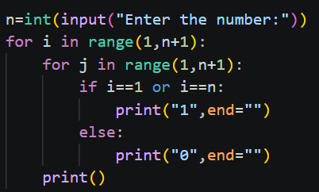 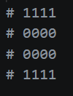
29. 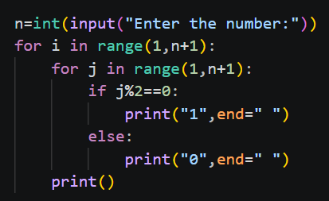 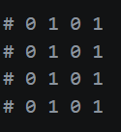
30. 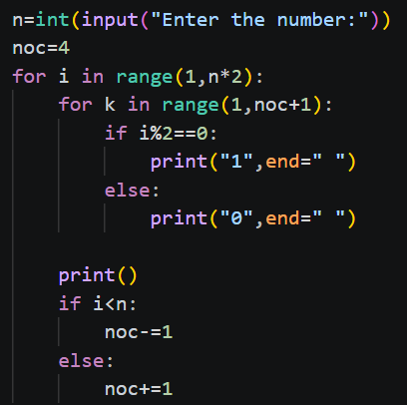 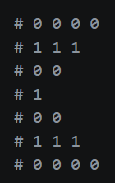

Alphabetic Patterns:
- Each and every character is internally represented as integers .These representation is called “ASCII” values.
- The extended version of ASCII value UNICODE values
- ASCII values have 256 character, ranging for 0-255 character
  - ‘ ’(space)32
  - ‘0’ to ‘9’48 to 57
  - ‘A’ to ‘Z’65 to 90
  - ‘a’ to ‘z’ 97 to 122
- Ordinal function: ord()
  - Id returns the integer representation of the provided sing;e character
  - Syn ord(char)
- Id returns the character representation of the provided whole number
  - Syn chr(Whole number)
LOGIC:
- Uppercase char(64+val)
- Lowercase char(96+val)

Hollow Pattern:

